Superlative Adjectives

🔹 What Are Superlative Adjectives?
# Source: AI Source: Provided by: [Data Path: Persons Table -> ID Column: 1, Name_En Column: Motasem Essam] -> From: [Chatgpt (GPT-4-turbo)] on [7/27/2025]
Superlative adjectives are used to compare three or more people, animals, things, or places.
They show that one thing has the highest or lowest degree of a quality.

✅ How to Form Superlative Adjectives
# Source: AI Source: Provided by: [Data Path: Persons Table -> ID Column: 1, Name_En Column: Motasem Essam] -> From: [Chatgpt (GPT-4-turbo)] on [7/27/2025]
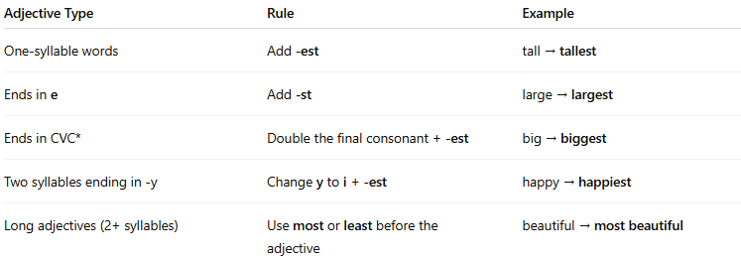
Adjective Type | Rule | Example
One-syllable words | Add -est | tall → tallest
Ends in e | Add -st | large → largest
Ends in CVC* | Double the final consonant + -est | big → biggest
Two syllables ending in -y | Change y to i + -est | happy → happiest
Long adjectives (2+ syllables) | Use most or least before the adjective | beautiful → most beautiful
CVC = consonant–vowel–consonant (e.g., big, hot)

📚 Examples in Sentences
# Source: AI Source: Provided by: [Data Path: Persons Table -> ID Column: 1, Name_En Column: Motasem Essam] -> From: [Chatgpt (GPT-4-turbo)] on [7/27/2025]
- He is the tallest boy in the class.
- This is the most interesting movie I’ve seen.
- She’s the best player on the team.
- That was the least expensive option.

❗ Key Notes
# Source: AI Source: Provided by: [Data Path: Persons Table -> ID Column: 1, Name_En Column: Motasem Essam] -> From: [Chatgpt (GPT-4-turbo)] on [7/27/2025]
- Always used when comparing more than two things.
- Often preceded by "the" (because it refers to one specific thing).
✅ She is the smartest student.
✅ This is the most important rule.

🧠 Common Irregular Superlative Adjectives
# Source: AI Source: Provided by: [Data Path: Persons Table -> ID Column: 1, Name_En Column: Motasem Essam] -> From: [Chatgpt (GPT-4-turbo)] on [7/27/2025]
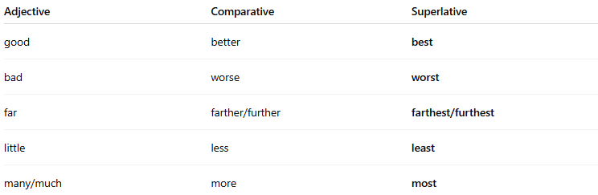
Adjective | Comparative | Superlative
good | better | best
bad | worse | worst
far | farther/further | farthest/furthest
little | less | least
many/much | more | most

Superlative Adjectives vs. Comparative Adjectives
# Source: AI Source: Provided by: [Data Path: Persons Table -> ID Column: 1, Name_En Column: Motasem Essam] -> From: [Chatgpt (GPT-4-turbo)] on [7/27/2025]
Both superlative and comparative adjectives are used to compare, but they differ in how many things they compare and how they are formed.

✅ Key Differences
# Source: AI Source: Provided by: [Data Path: Persons Table -> ID Column: 1, Name_En Column: Motasem Essam] -> From: [Chatgpt (GPT-4-turbo)] on [7/27/2025]
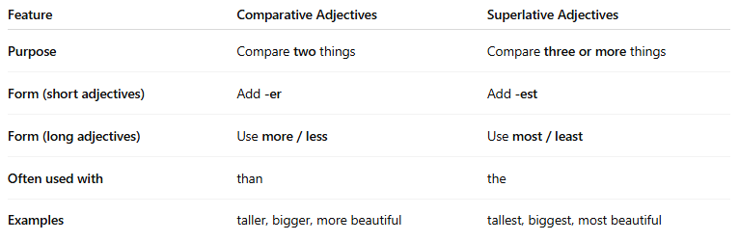

Feature | Comparative Adjectives | Superlative Adjectives
Purpose | Compare two things | Compare three or more things
Form (short adjectives) | Add -er | Add -est
Form (long adjectives) | Use more / less | Use most / least
Often used with | than | the
Examples | taller, bigger, more beautiful | tallest, biggest, most beautiful

📚 Examples in Sentences

Comparative:
# Source: AI Source: Provided by: [Data Path: Persons Table -> ID Column: 1, Name_En Column: Motasem Essam] -> From: [Chatgpt (GPT-4-turbo)] on [7/27/2025]
- Sarah is taller than Emma.
- This book is more interesting than that one.

Superlative:
# Source: AI Source: Provided by: [Data Path: Persons Table -> ID Column: 1, Name_En Column: Motasem Essam] -> From: [Chatgpt (GPT-4-turbo)] on [7/27/2025]
- Sarah is the tallest girl in the class.
- This is the most interesting book I’ve read.

🧠 Important Rules
# Source: AI Source: Provided by: [Data Path: Persons Table -> ID Column: 1, Name_En Column: Motasem Essam] -> From: [Chatgpt (GPT-4-turbo)] on [7/27/2025]
- Comparative = Comparing two nouns.
→ "John is faster than Sam."
- Superlative = Showing the highest/lowest degree among three or more.
→ "John is the fastest in the group."

